# 

# **Detailed Findings**

**Finding #1**

|  |  |
| --- | --- |
| **Heuristic(s)** | * Match between system and the real world * Consistency and standards |
| **Feedback / Issues** | * The language used for the description of each car are unclear to those who do not understand cars. * The symbols and pictures are very confusing |
| **Screen / Scope** | Homepage |
| **Severity** | Medium |
| **Solutions and Trade-offs** | * Have a picture and title for each car to keep it more simple. |
| **Screen Captures** | See below |

## 

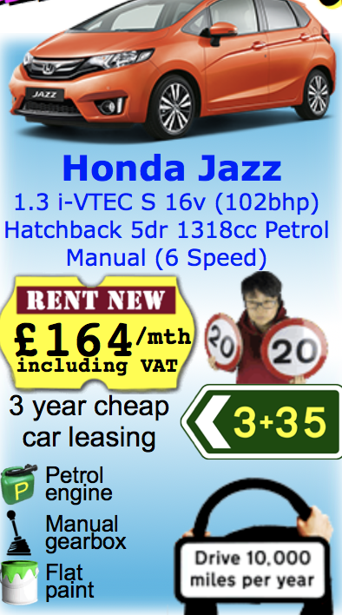 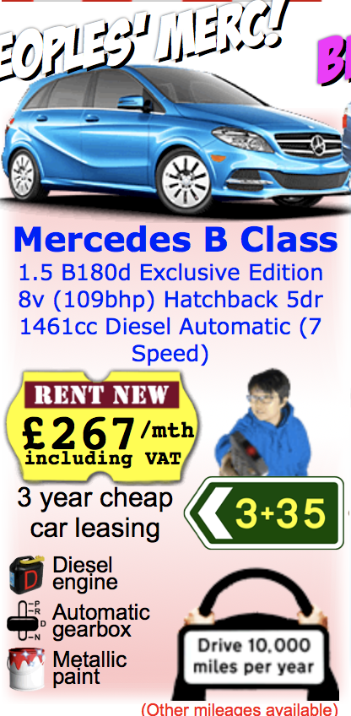

**Finding #2**

|  |  |
| --- | --- |
| **Heuristic(s)** | * Aesthetic and minimalist design |
| **Feedback / Issues** | * The list on the side of the screen goes past the bottom of the main screen causing a lot of white space. |
| **Screen / Scope** | Homepage |
| **Severity** | Low |
| **Solutions and Trade-offs** | * Make drop down bars to store the information in each category that you can drop down one at a time. Do this instead of having it all out at one time. |
| **Screen Captures** | See below |

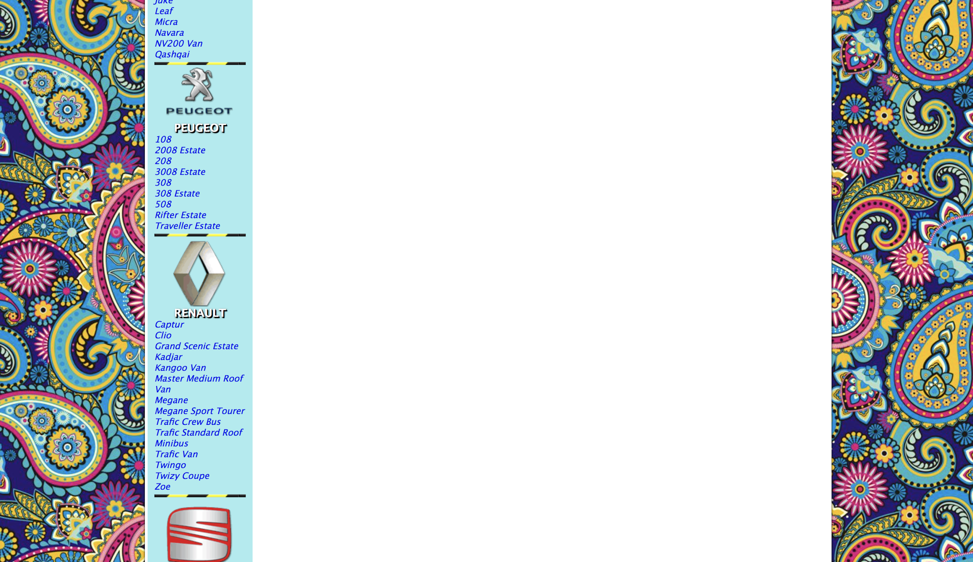

Finding #3 - Tyre’ Harrison

|  |  |
| --- | --- |
| **Heuristic(s)** | * match between system and the world * aesthetic and minimalist design |
| **Feedback / Issues** | * It is a whole bunch of information without context |
| **Screen / Scope** | Personal Price List Page |
| **Severity** | Low |
| **Solutions and Trade-offs** | * Move specific information about car on the car’s personal page |
| **Screen Captures** | below |

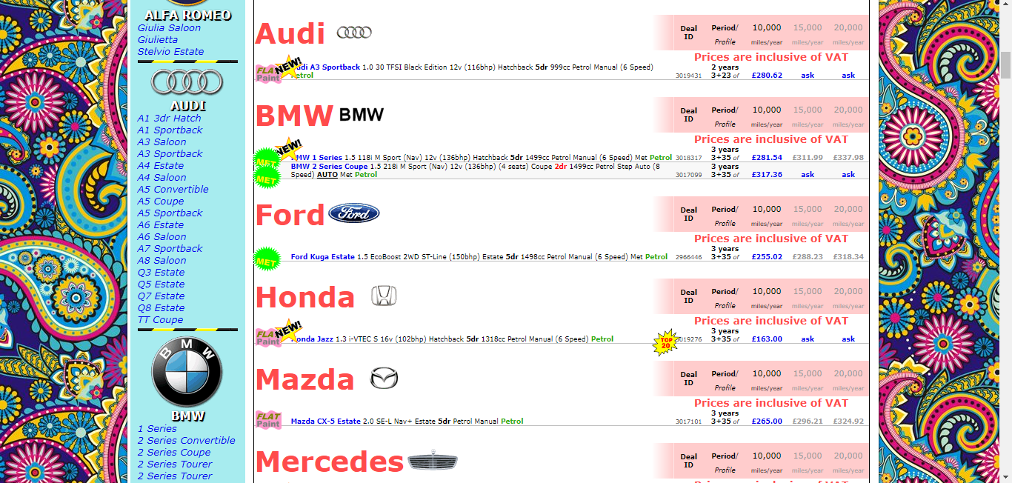

Finding #4: Physical address

|  |  |
| --- | --- |
| **Heuristic(s)** | * Flexibility and efficiency of use |
| **Feedback / Issues** | The physical address of the dealership is buried within the website |
| **Screen / Scope** | My Location |
| **Severity** | Low |
| **Solutions and Trade-offs** | Move the physical address |
| **Screen Captures** | See below |

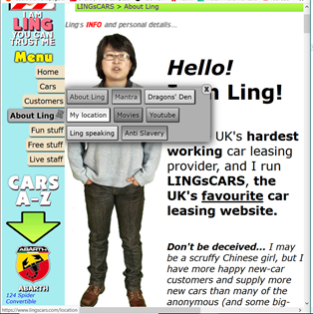

Finding #5

|  |  |
| --- | --- |
| **Heuristic(s)** | * Aesthetic and minimalist design * Flexibility and efficiency of use |
| **Feedback / Issues** | * There is so much information scattered everywhere it is difficult for users to follow. |
| **Screen / Scope** | Navigation bar |
| **Severity** | medium |
| **Solutions and Trade-offs** | * Eliminate useless information. |
| **Screen Captures** | See below |

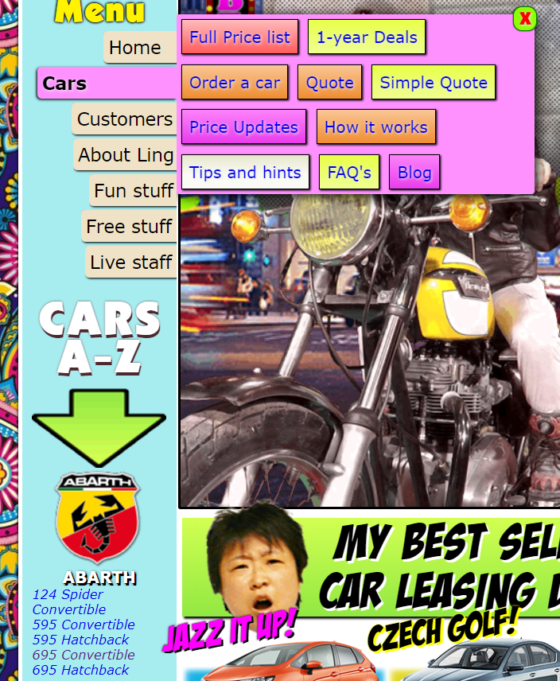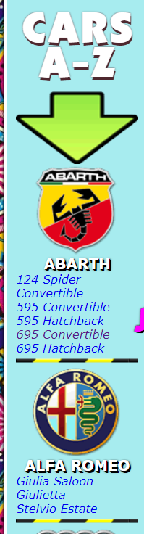

Finding #6: Visual Clutter

|  |  |
| --- | --- |
| **Heuristic(s)** | * Aesthetic and Minimalist Design * Consistency and Standards |
| **Feedback / Issues** | * The aesthetics are awful, way too busy of a site. * Too many moving elements, both literally and graphically (the floral pattern in the back is completely unnecessary.) |
| **Screen / Scope** | Home page and just general aesthetics |
| **Severity** | Medium |
| **Solutions and Trade-offs** | * Eliminate ALL visual clutter, gifs, graphics, etc * The bright aesthetic is allowed, but the clashing colors and designs are clashing to the eyes, and distract from the important information. * Choose an appropriate color scheme, and stick to basic color theory |
| **Screen Captures** | See below |

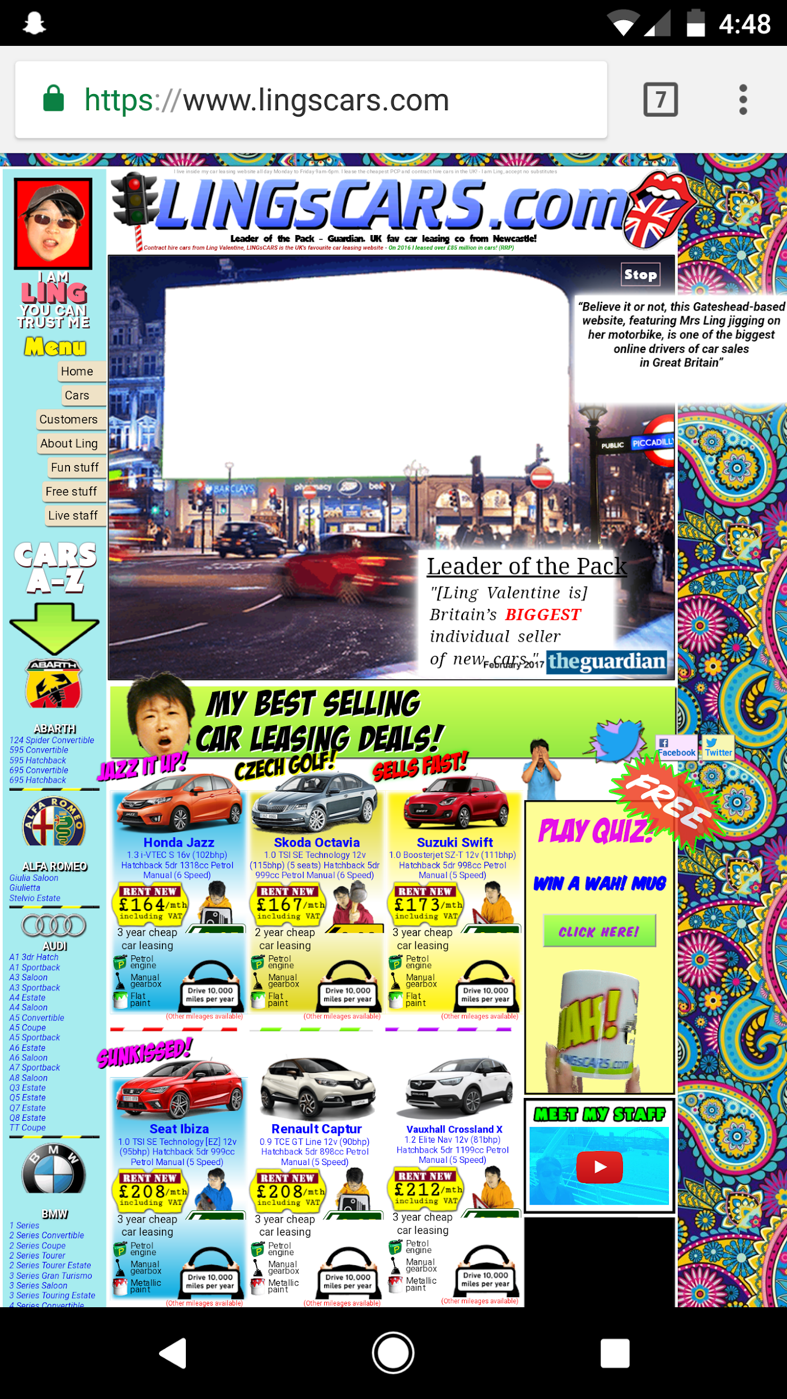

Finding #7: Navigation is difficult

|  |  |
| --- | --- |
| **Heuristic(s)** | * User Control and Freedom * Recognition versus Recall * Flexibility and Efficiency of Use |
| **Feedback / Issues** | * Navigation buttons are all over the place, no central navbar. * Important functions are difficult to locate * Clickable elements are not intuitive, once again making navigation difficult |
| **Screen / Scope** | Home page |
| **Severity** | High |
| **Solutions and Trade-offs** | * Add a navbar that is accessible from wherever one is on the page * Eliminate unnecessary clutter to allow users to find important functions |
| **Screen Captures** | See below |

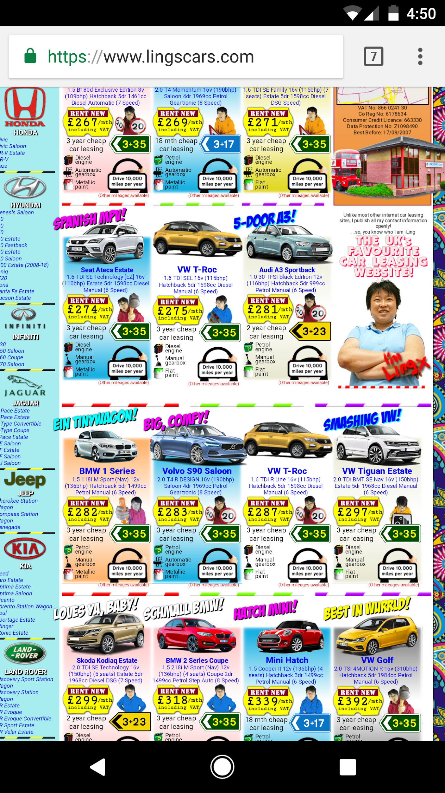

Finding #8: contact info

|  |  |
| --- | --- |
| **Heuristic(s)** | * Error Prevention * Flexibility and efficiency of use |
| **Feedback / Issues** | * The telephone contact number is also buried within the site as well as not even existing on the mobile version of the site. |
| **Screen / Scope** | My location |
| **Severity** | Low |
| **Solutions and Trade-offs** | * Move to an easily locatable section of the home screen |
| **Screen Captures** | See below |

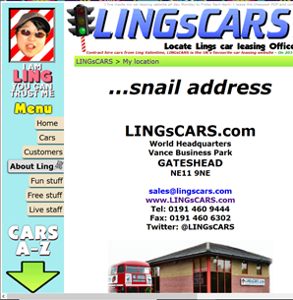

Finding # 9 - Tyre’ Harrison

|  |  |
| --- | --- |
| **Heuristic(s)** | * User control and freedom * Match between system and the world * Aesthetic and minimalist design |
| **Feedback / Issues** | * it has a lot going on and I can barely pick out what is important on page |
| **Screen / Scope** | Car info page/ quote page |
| **Severity** | low |
| **Solutions and Trade-offs** | * take out some of information |
| **Screen Captures** | See below |

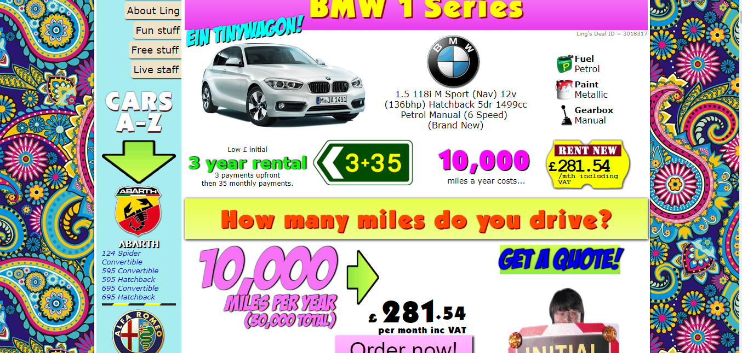

Finding #10

|  |  |
| --- | --- |
| **Heuristic(s)** | * Visibility of system status * Match between system and real world * Consistency and standards * Aesthetic and minimal design |
| **Feedback / Issues** | * Doesn’t inform user they are navigating to a new page. Isn’t clear on what they are logging into. * The constant use of “Ling” could be confusing to users. * There is no “sign up” option. A user cannot enter a password until after entering an email. |
| **Screen / Scope** | Log in screen |
| **Severity** | Low |
| **Solutions and Trade-offs** | * Inform users of navigation and what they are accessing. * Use natural language * Give the user a “sign up” option. |
| **Screen Captures** | See below |

